IP2

Follow these steps and commands to complete the installation.

Enter the following command in the terminal to obtain WiringPi using GIT:

sudo apt-get update

sudo apt-get upgrade

git clone git://[git.drogon.net/wiringPi](http://git.drogon.net/wiringPi)

After the cloning operation is completed, go to the wiring folder and update the latest WiringPi.

cd wiringPi

git pull origin

Run the build file to start the installation.

./build

The new build script will compile and install it all for you. It does use the sudo command at one point, so you

may wish to inspect the script before running it.

Run the gpio command to check the installation:

gpio -v

gpio readall

Obtain the Project Code  
After the above work is done, you can visit our official website (http://www.freenove.com) or our github (https://github.com/freenove) to download the latest project code. We provide both C language and Python language code for each project in order to apply to user skilled in different languages.  
Method for obtaining the code:  
In the pi directory of the RPi terminal, enter the following command:  
cd ~  
git clone https://github.com/freenove/Freenove_RFID_Starter_Kit_for_Raspberry_Pi   
After the download is completed, a new folder "Freenove_RFID_Starter_Kit_for_Raspberry_Pi" is generated, which contains all the tutorials and code.  
If you think the folder name is too long. You can rename it by following command.  
mv Freenove_RFID_Starter_Kit_for_Raspberry_Pi xxx  
Among them, "xxx" represents the new folder name. If you rename the folder, you must change every “Freenove_RFID_Starter_Kit_for_Raspberry_Pi" to new folder name in later commands which contain folder name.

Python

If you want to set Python3 as default Python actuators. please follow the steps below.

1. Enter directory /usr/bin

cd /usr/bin

2. Delete the old python link.

sudo rm python

3. Creat new python links to python3.

sudo ln –s python3 python

4. Execute python to check whether the link succeeds.

python

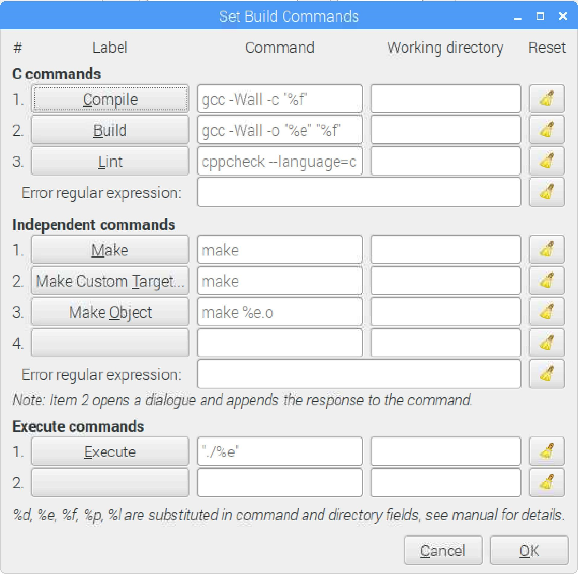

BCM :

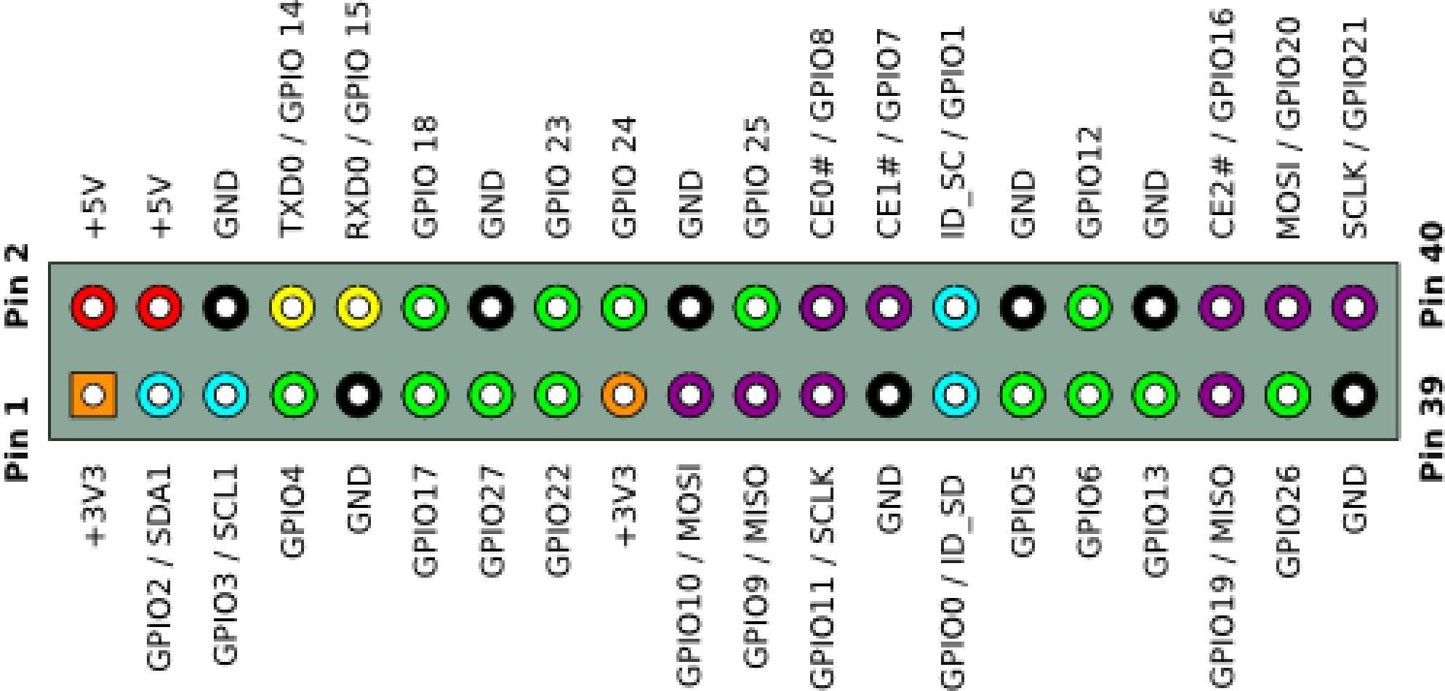

<http://pinout.xyz/>

http://wiringpi.com/

<https://projects.drogon.net/raspberry-pi/wiringpi/pins/>